**Web Development Task 1**

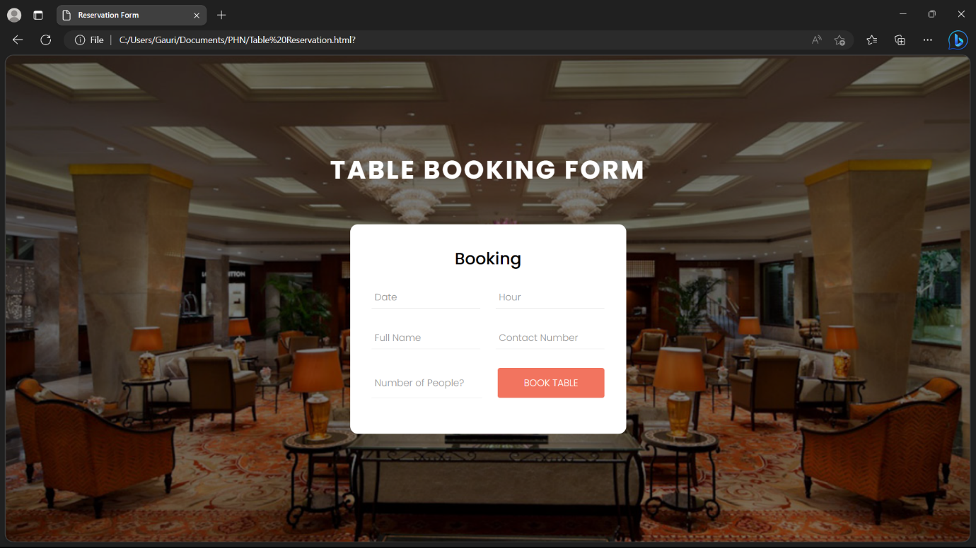

The above picture is the basic layout of the TABLE BOOKING FORM for a restaurant's website consisting of a block in which the heading “Booking” is given and there are fields of Date, Hour, Full Name, Contact number and Number of People along with a “BOOK TABLE” button.

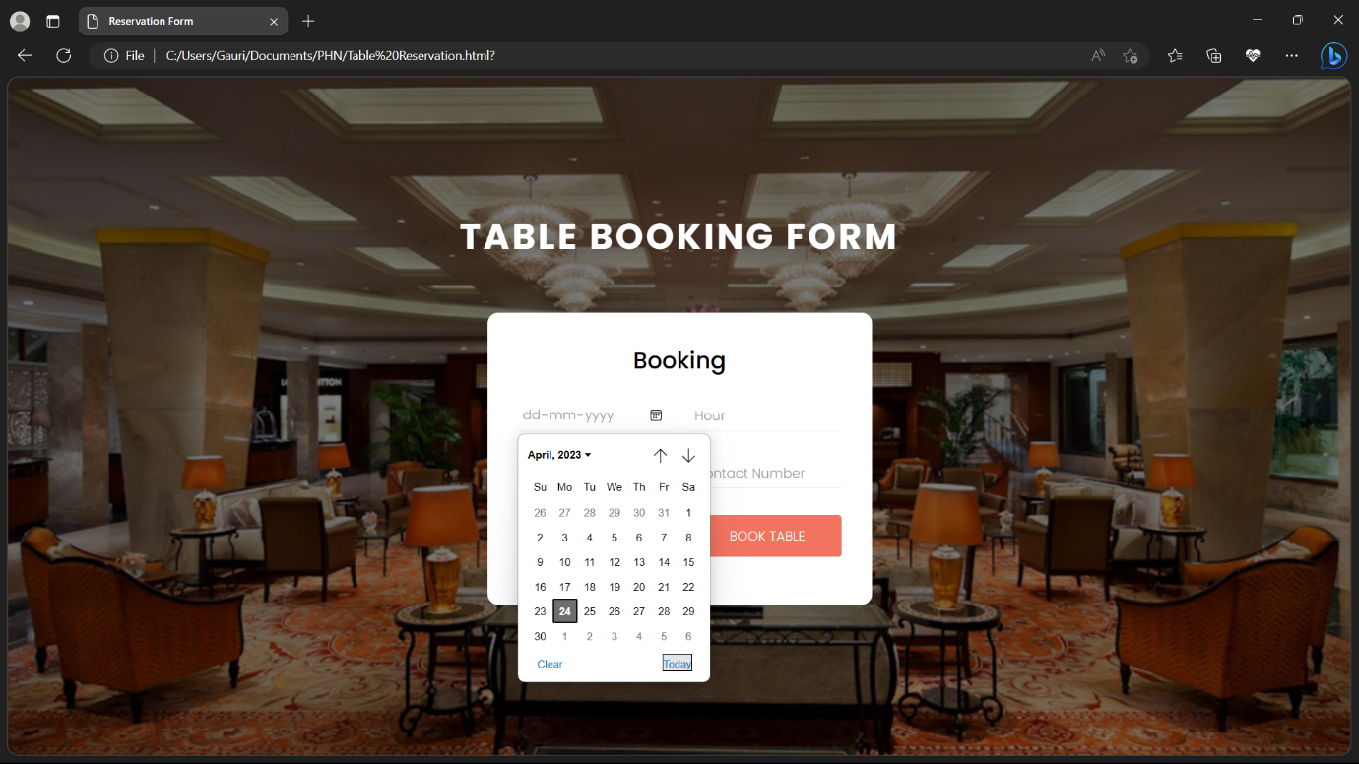

In the above picture the user can add their desired date of the table booking.

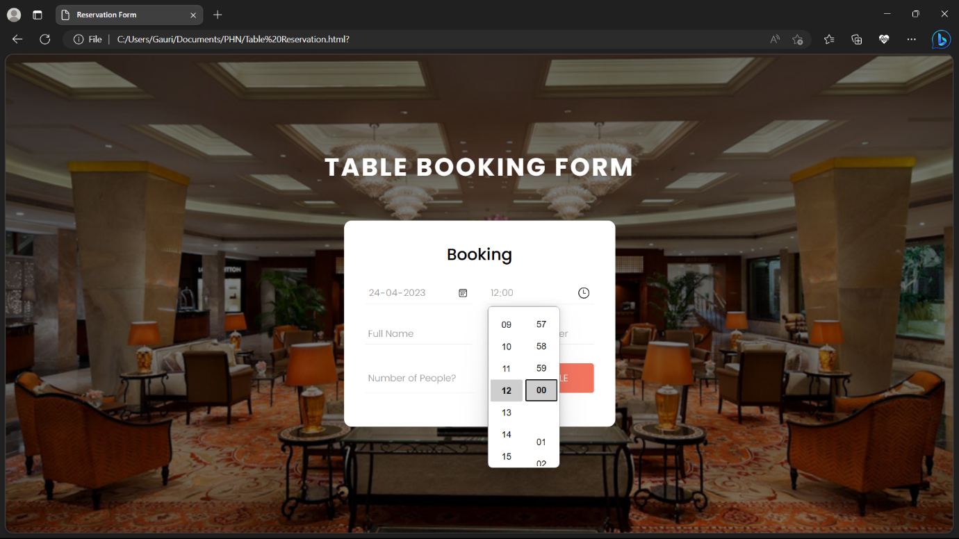

And they can add their desired time for the particular booking.

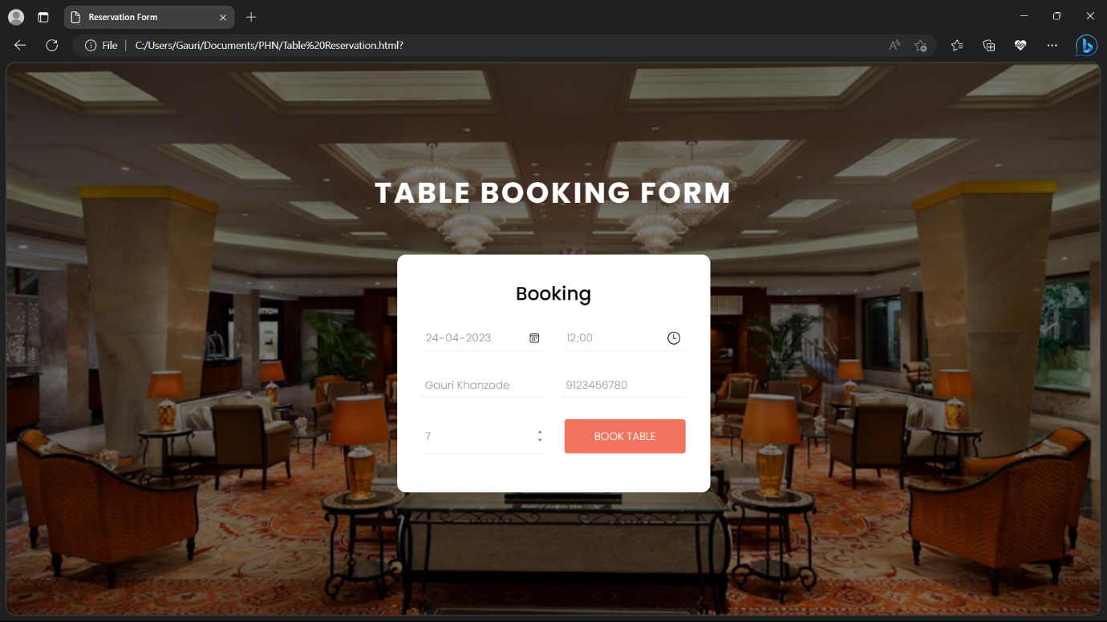

Next they can go on filling their relevant information in the remaining fields i.e. Full name, Contact number and Number of people.

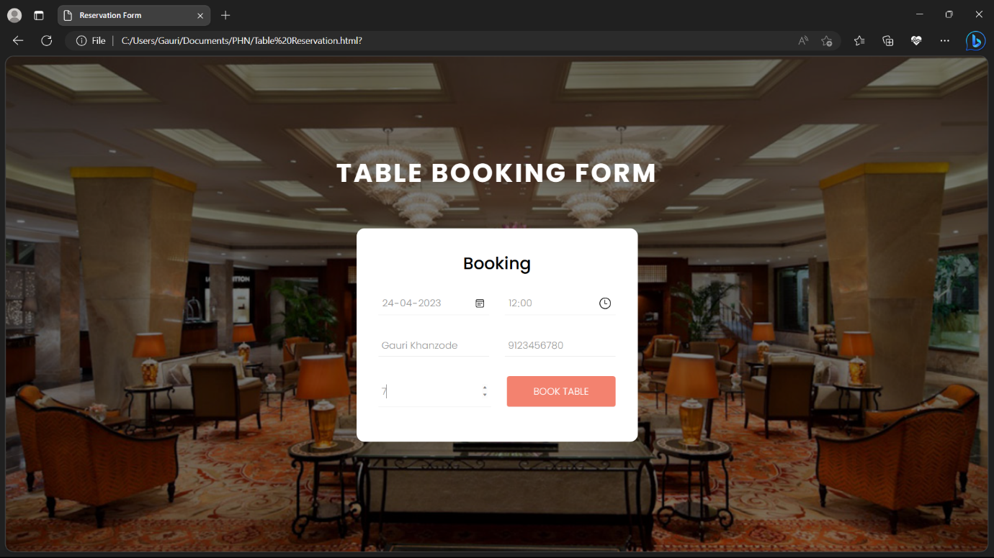

Finally they can press on "BOOK TABLE" button and the form will be submitted.

Their entries will be recorded on the staff's side through a server.

Thank you.